Local VCS
# Source: AI Source: Provided by: [Data Path: Persons Table -> ID Column: 1, Name_En Column: Motasem Essam] -> From: [ChatGPT] on [2/15/2026]
A Local Version Control System (Local VCS) is a basic type of version control that tracks file changes only on your local machine — without any collaboration or central repository.

🧠 In Simple Terms:
# Source: AI Source: Provided by: [Data Path: Persons Table -> ID Column: 1, Name_En Column: Motasem Essam] -> From: [ChatGPT] on [2/15/2026]
A local VCS keeps a history of changes on your computer, but doesn’t support working with others or syncing over a network.

🗂️ How It Works:
# Source: AI Source: Provided by: [Data Path: Persons Table -> ID Column: 1, Name_En Column: Motasem Essam] -> From: [ChatGPT] on [2/15/2026]
- It saves snapshots of your files each time you commit.
- You can go back to an older version at any time.
- The version history is stored in a special folder on your local drive.

📦 Example of a Local VCS:
# Source: AI Source: Provided by: [Data Path: Persons Table -> ID Column: 1, Name_En Column: Motasem Essam] -> From: [ChatGPT] on [2/15/2026]
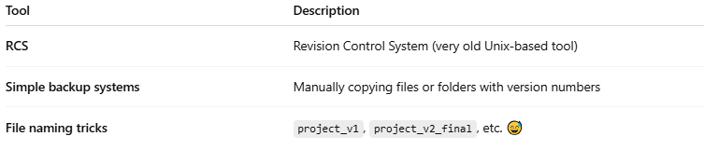

Tool | Description
RCS | Revision Control System (very old Unix-based tool)
Simple backup systems | Manually copying files or folders with version numbers
File naming tricks | project_v1, project_v2_final, etc. 😅

📉 Limitations of Local VCS:
# Source: AI Source: Provided by: [Data Path: Persons Table -> ID Column: 1, Name_En Column: Motasem Essam] -> From: [ChatGPT] on [2/15/2026]
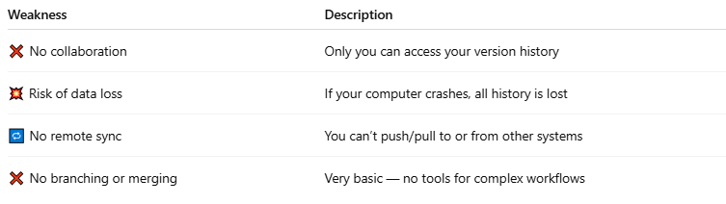

Weakness | Description
❌ No collaboration | Only you can access your version history
💥 Risk of data loss | If your computer crashes, all history is lost
🔁 No remote sync | You can’t push/pull to or from other systems
❌ No branching or merging | Very basic — no tools for complex workflows

✅ Benefits (in early days or solo projects):
# Source: AI Source: Provided by: [Data Path: Persons Table -> ID Column: 1, Name_En Column: Motasem Essam] -> From: [ChatGPT] on [2/15/2026]
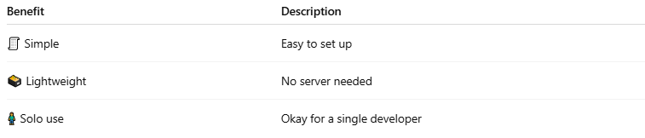

Benefit | Description
🧾 Simple | Easy to set up
🗃️ Lightweight | No server needed
🧍 Solo use | Okay for a single developer

🆚 Local VCS vs Centralized vs Distributed
# Source: AI Source: Provided by: [Data Path: Persons Table -> ID Column: 1, Name_En Column: Motasem Essam] -> From: [ChatGPT] on [2/15/2026]
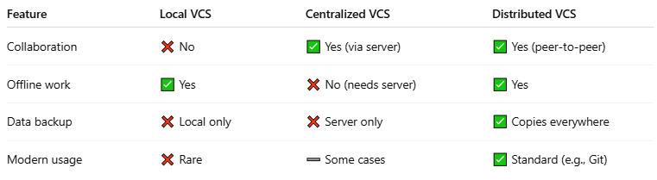

Feature | Local VCS | Centralized VCS | Distributed VCS
Collaboration | ❌ No | ✅ Yes (via server) | ✅ Yes (peer-to-peer)
Offline work | ✅ Yes | ❌ No (needs server) | ✅ Yes
Data backup | ❌ Local only | ❌ Server only | ✅ Copies everywhere
Modern usage | ❌ Rare | ➖ Some cases | ✅ Standard (e.g., Git)

🧠 Summary:
# Source: AI Source: Provided by: [Data Path: Persons Table -> ID Column: 1, Name_En Column: Motasem Essam] -> From: [ChatGPT] on [2/15/2026]
A Local VCS:
- Tracks file versions on your own computer
- Is suitable for solo work
- Lacks support for collaboration, remote sync, or advanced features

